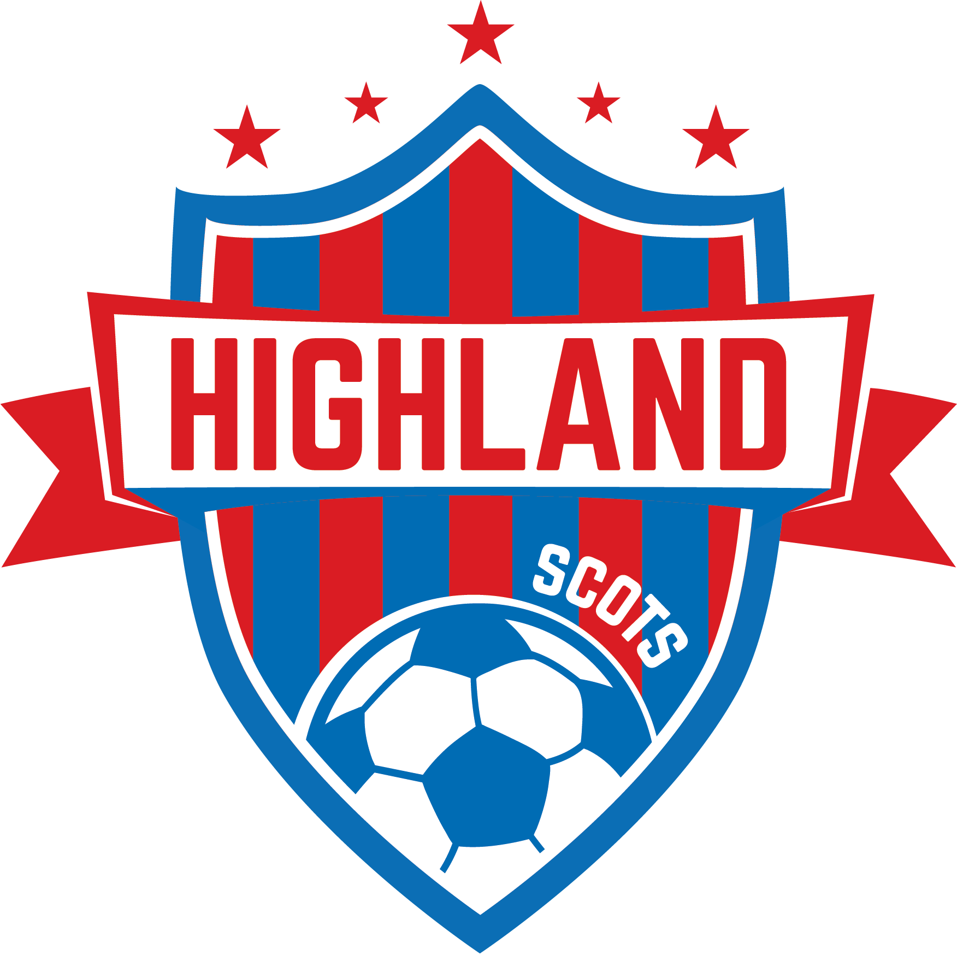

Highland Scots Soccer Team Sponsorship Form
Contact Tina with any questions: vp@highlandscotssoccer.org
Our website: www.highlandscotssoccer.org

FALL SEASON 2020 DATE: __________________ Submit by: ____________________

Business Name (as it will appear on uniforms): Please no phone numbers. ______________________________________________________________________________
Contact person:
Address: _____________________________________________________________________
Phone: _______________________________________________________________________
E-mail: _____________________________________

Logo’s need to be send to vp@highlandscotssoccer.org

Sponsorship Category:

Team Sponsorship--- $225_______________
Business Logo on Highland Scots Soccer Website banner
Company Name on Player Game Shirts

Make checks payable to Highland Soccer Club
P.O. Box 194, Marengo, Ohio 43334

Our sincerest Thank You for your support of Highland Scots Soccer!

